Lab 3 – Amazon S3 Security Responsibilities

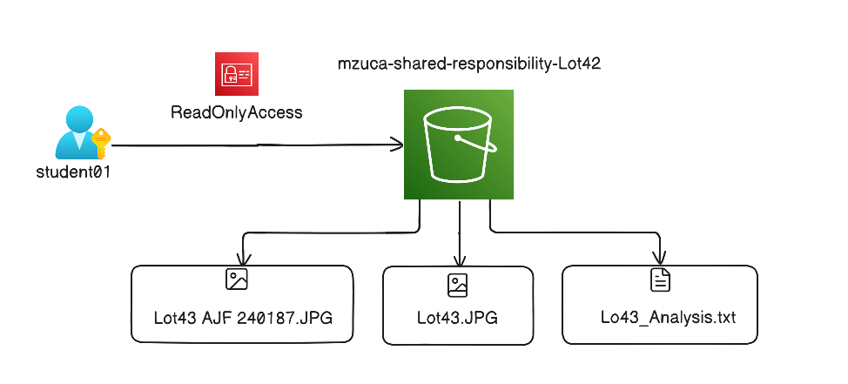

Task 1
Create an S3 Bucket
Name
- mzuca-shared-responsibility-lot42
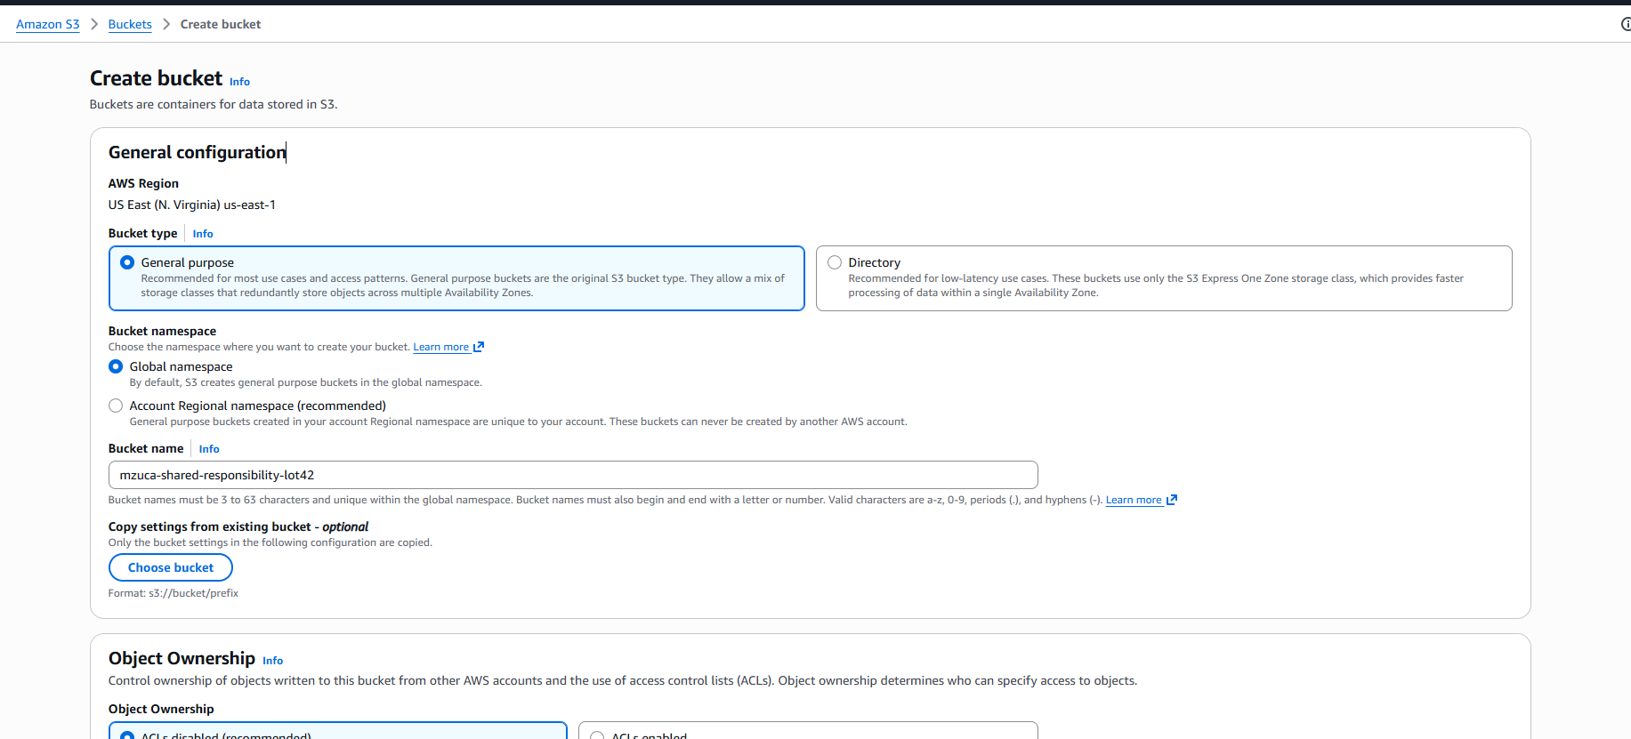

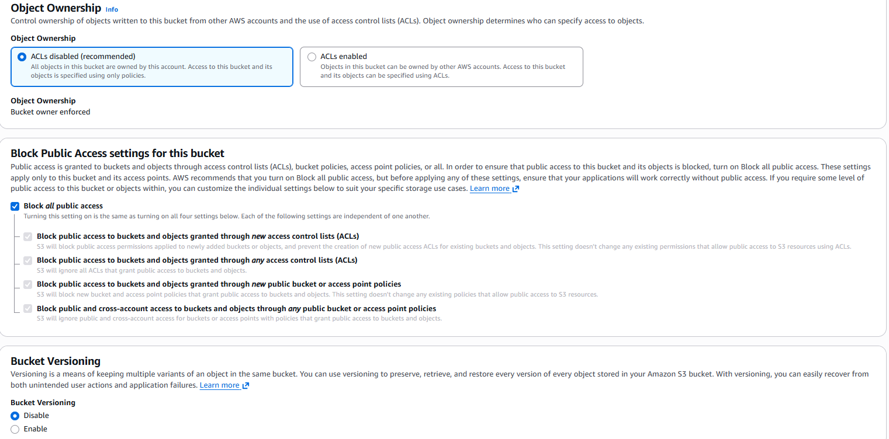

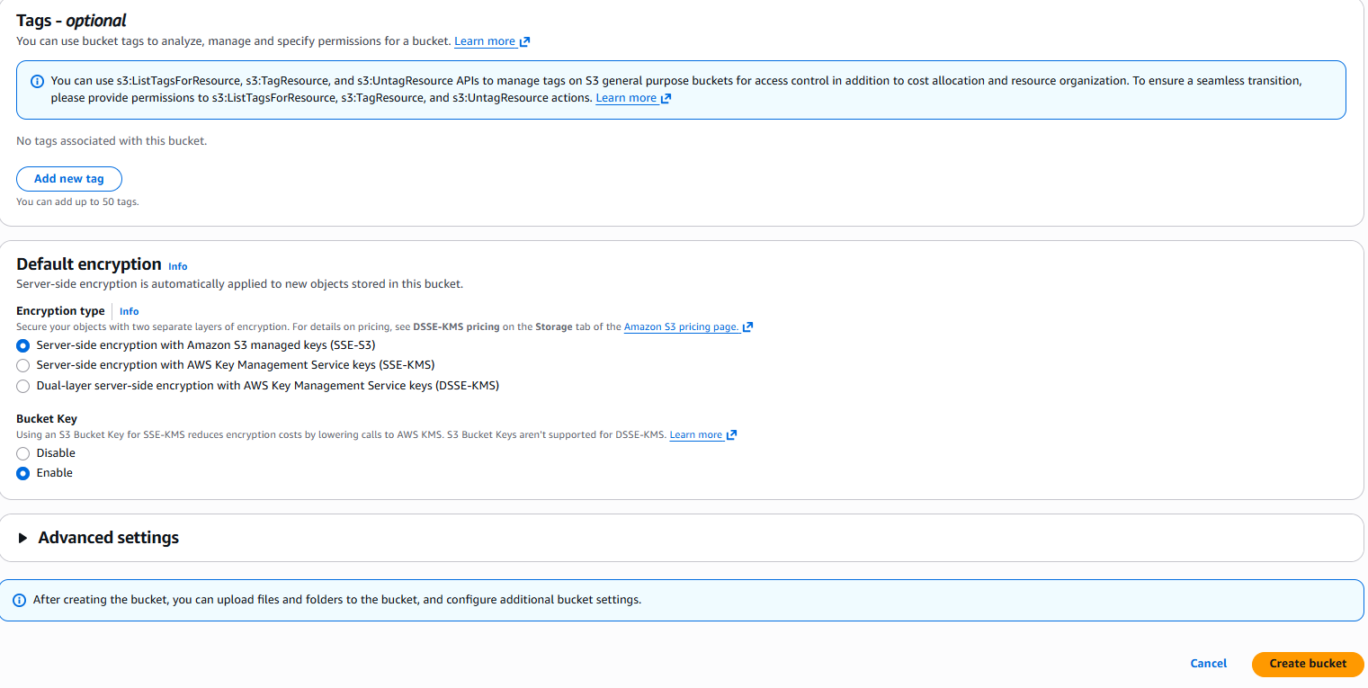
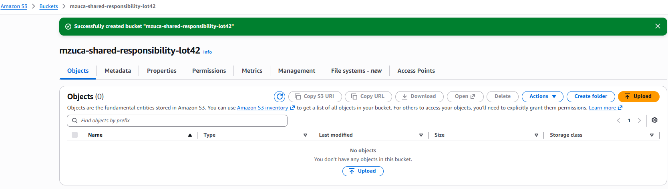
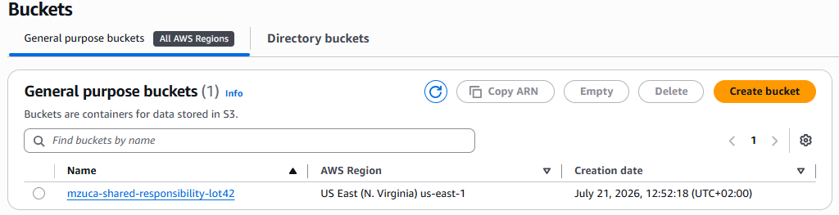

Task 2
Uploaded Files
- Lot43 AJF 240187.JPG
- Lot43.JPG
- Lo43_Analysis.txt

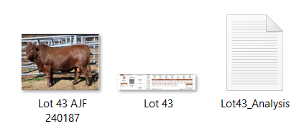
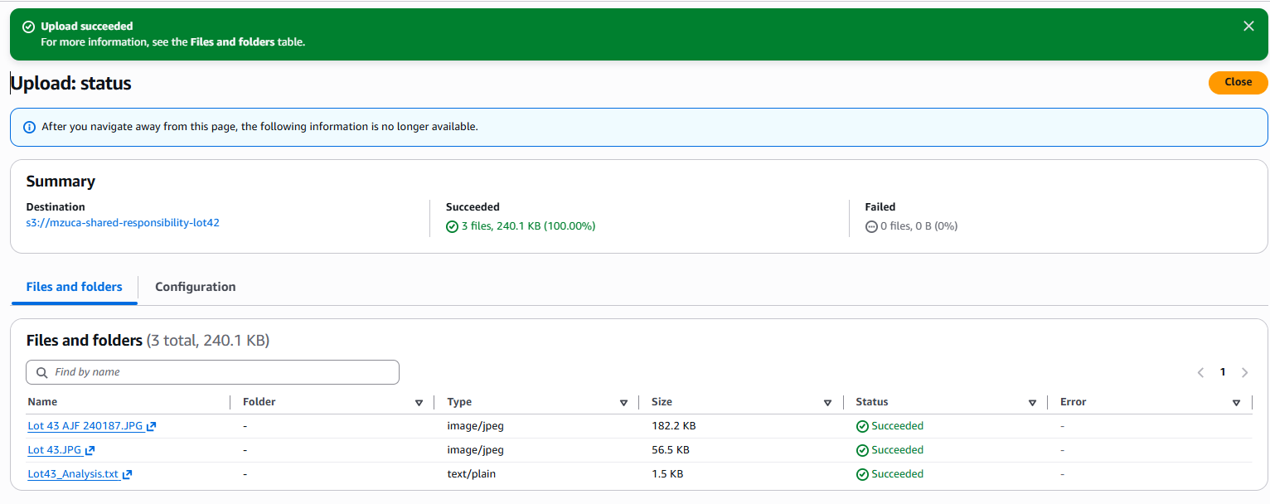

Task 3 Review
Properties & Versioning
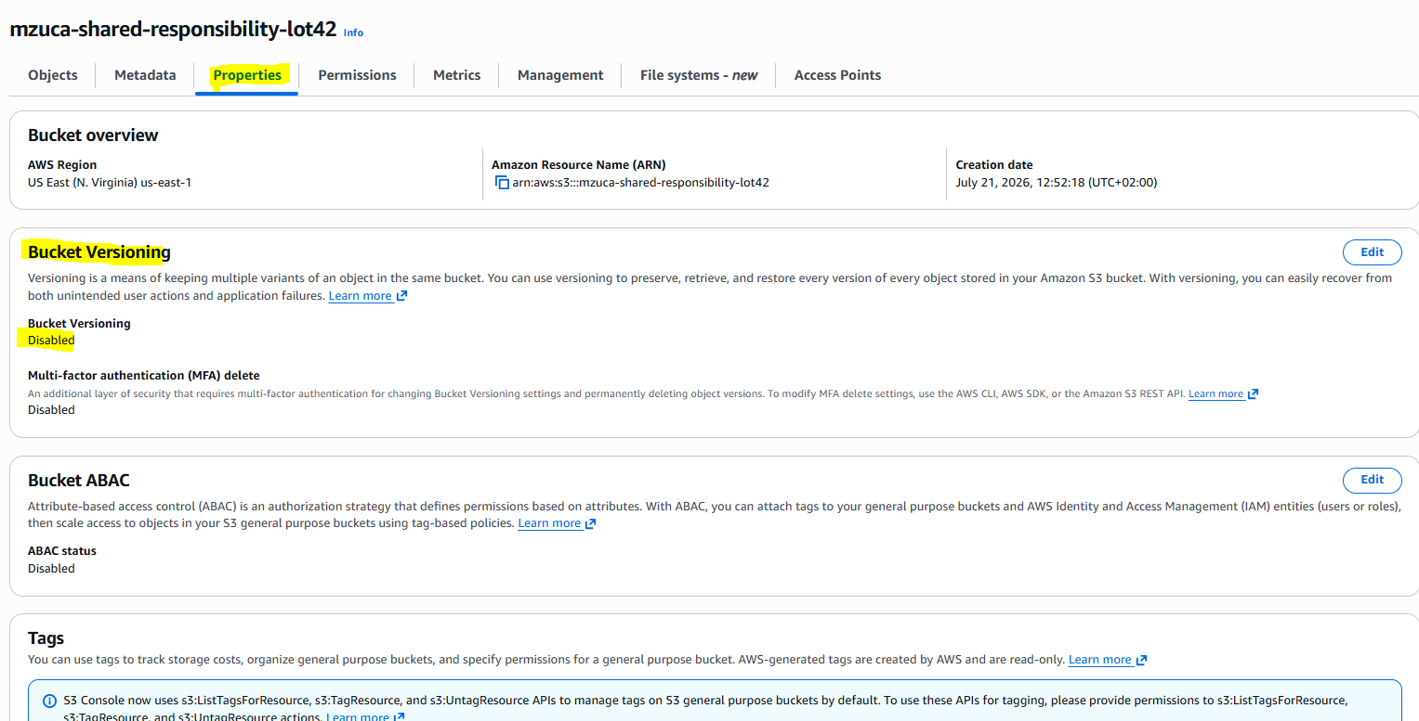
Encryption
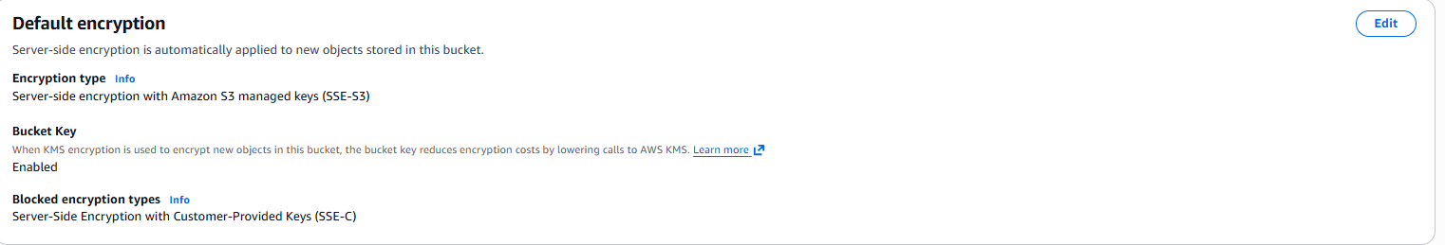

Permissions & Bucket Policy
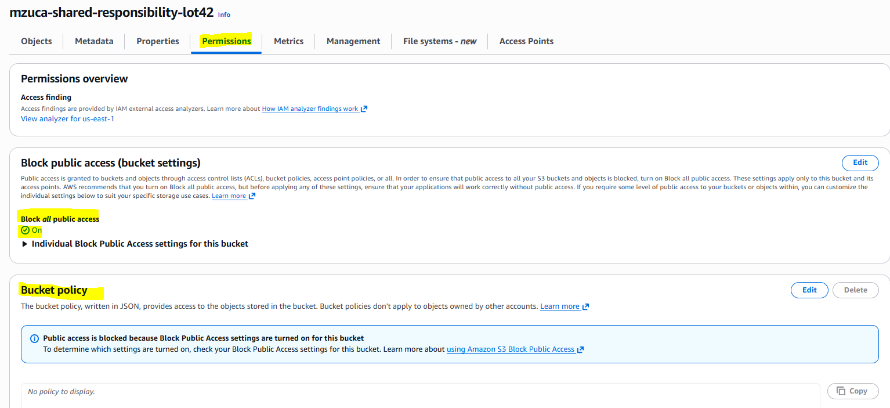

Task 4 Enable

Block Public Access
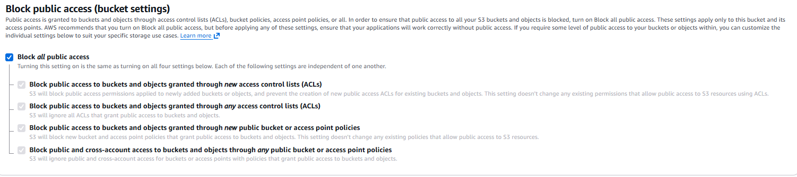
Versioning Enable
